Staff access to BKSB Live

By default, all staff at HRC have Learner access to BKSB Live. This means you can undertake assessments yourself, either to see what they’re like, or as part of your own CPD. Follow the instructions below to access BKSB Live and set your password.

To search for students’ Initial Assessment results in BKSB Live, you need Tutor access. Once you have set your BKSB password, you need to email the Quality team at quality@hrc.ac.uk to have your access raised to Tutor level.

Access BKSB Live and set your password:

- Open Internet Explorer (or another browser, e.g. Safari or Chrome) and go to moodle.hrc.ac.uk

- Click on the Skills Assessment icon down the left hand side of the page.

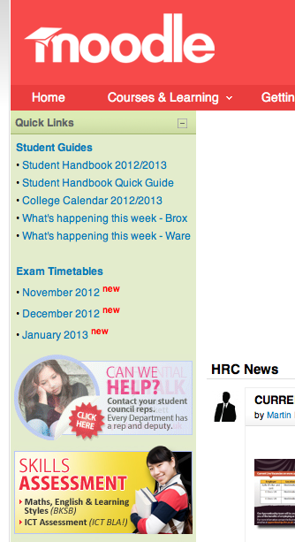

- Click on any link which says BKSB Live (e.g. under At HRC for an interview/ assessment).

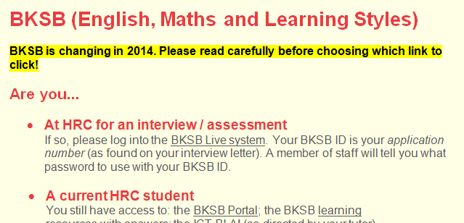
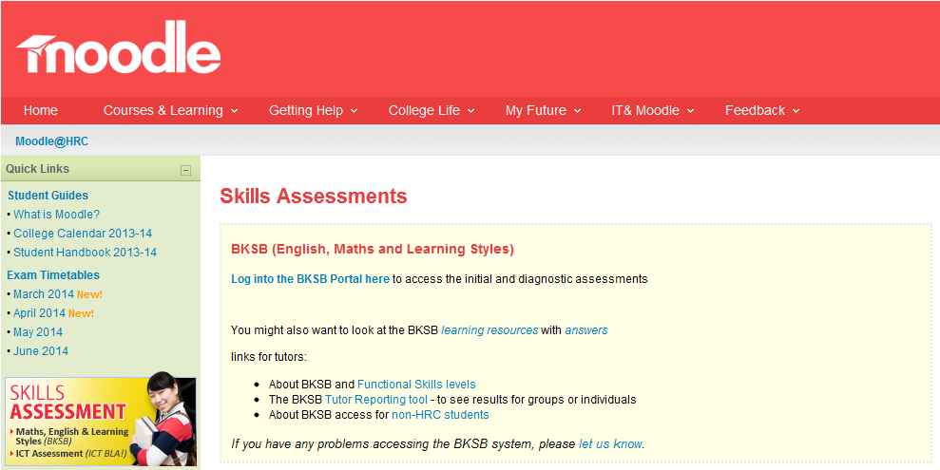

- In the BKSB Live ID box, type your usual HRC username.
In the Password box, type the word password. Then click Login.

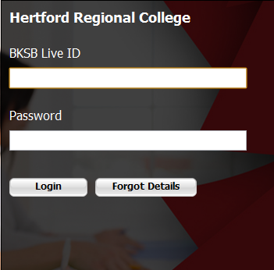
jbloggs
password

- Next, check that your name is correct and click Confirm.

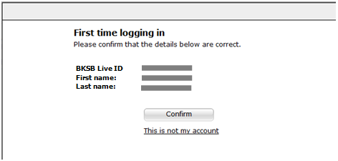

- Then change your password to something only you will know. To do this, type password into the Old password box and type a new password into the New password and Retype password boxes. Click Change Password.
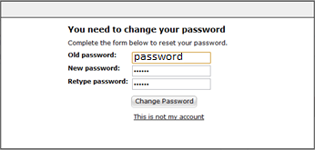

- Type in your HRC email address and click the Save email address button.

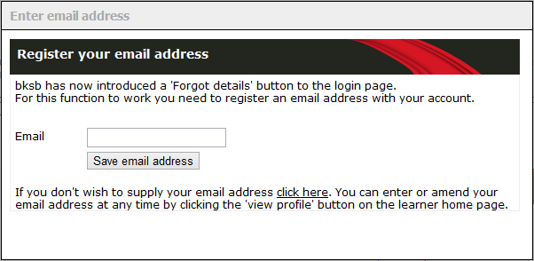
jbloggs@hrc.ac.uk

Everyone in BKSB is a learner by default. If you are given Tutor access, you can switch between Learner and Tutor access by clicking your name at top right of the BKSB home page.
