Week 2: Instruction sheet for BKSB facilitators
(DEM team in timetabled classes)

Passwords for…

Computers: Students log into the PCs/Macs with the student number and password they set at enrolment. If someone has forgotten their password, please send them to the LC for a swift reset. Logging into the computers can take time, so have them log into the computer as soon as they enter the room. You can introduce the concept of BKSB etc whilst they wait for the PCs to login.
BKSB: Username = student number
Password = the one they set when they first accessed BKSB in Week 1.
If for some reason they haven’t been into BKSB yet, their password is the word password (they will be forced to change this after they have logged in).

What do students do in BKSB in Week 2?

The ultimate goal is that by the end of Week 2, all English and maths students will have completed a relevant DIAGNOSTIC.

- If the learner is enrolled on a Functional Skills course, they should already have completed an Initial Assessment in week 1, so BKSB will signpost the level of Functional Skills Diagnostic they should take with you in Week 2*.
- If they are enrolled on a GCSE or Functional GCSE:
  - If MATHS, they should have at least completed the GCSE Maths Overview and possibly started their GCSE Number Diagnostic in Week 1, which they can finish with you.
  - If ENGLISH, they should have at least started the GCSE Reading Diagnostic in Week 1, which they can finish with you.
If they complete their Diagnostic before or during your session, they can work on the learning materials that BKSB signposts for them.

Important!

*STEP 1
*
If a student was with us last year (or prior to that) and completed an Initial or a Diagnostic Assessment, their course page for Focus Functional Skills or GCSE Achieve will show them as having completed that assessment, so…

In that course, check under their Achievements tab to see when they did the assessment.

If Functional Skills, they should have completed an Initial Assessment this September (i.e. in Week 1).
- If they did, and they are now directed to do the Diagnostic Assessment, that’s good.
- If they did, but they are not directed to do the Diagnostic Assessment at the level indicated by the Initial Assessment, they need to click ‘retake’ Diagnostic (cog/gear icon). This will open the Diagnostic at the level corresponding to their latest Initial Assessment attempt.
- If they didn’t complete an Initial Assessment in Week 1, they need to retake the Initial Assessment now (via gear/cog icon at top right).

If GCSE, they should start, or continue, their Reading/Number Diagnostic with you. If they are directed to complete learning modules, check under View Course > Achievements (tab) to make sure they completed the Diagnostic in September this year.
- If they didn’t do it this year, they need to click ‘retake Diagnostic’ and follow the instructions.
If directed to do the GCSE Maths Overview, let them start/continue that first.

Retaking an assessment…
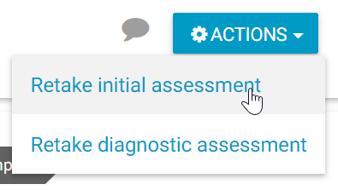
Student should click View Course (in either Focus Functional Skills or GCSE Achieve) > Actions > Retake…
