Week 1: Instruction sheet for BKSB facilitators
(Voc. Teams, DEM team, LC team)

Which assessments do students take in Week 1?

Virtually all FT students will have a sticker on their ID card lanyard identifying the BKSB assessments they need to do in week 1. If the student has no sticker, here’s how you work out which assessments they need to take:
- If they’re enrolled on a Functional Skill, they take the (maths or English) Initial Assessment
- If they’re enrolled on a GCSE or Functional GCSE – or if they already have a GCSE qualification – they need to take the relevant Diagnostic Assessment (GCSE Number for maths / GCSE Reading for English). UPDATE: BKSB have changed the way the GCSE Maths Diagnostics work. Students will be forced, automatically, to take an ‘Overview’ assessment before it lets them access the Diagnostic. Just let them work through this; they will continue with their maths tutor in week 2.

Passwords for…

Computers: Students log into the PCs/Macs with the student number and password they set at enrolment. If someone has forgotten their password, please send them to the LC for a swift reset. Logging into the computers can take time, so have them log into the computer as soon as they enter the room. You can introduce the concept of BKSB etc whilst they wait for the PCs to login.
BKSB: Username = student number
Password = the word password (they will be forced to change this after they have logged in)

Troubleshooting…
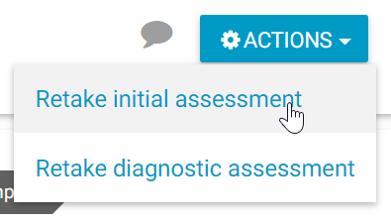
Q. Student has done an Initial Assessment in the past, so is directed to do something else, or;
Q. Student has done a GCSE Diagnostic Assessment in the past, so is directed to do something else
A. Student should click View Course > Actions > Retake…
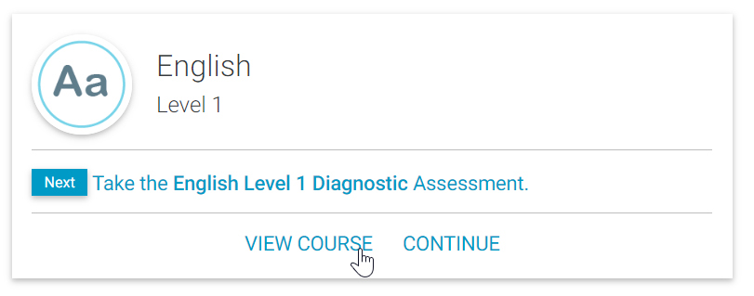

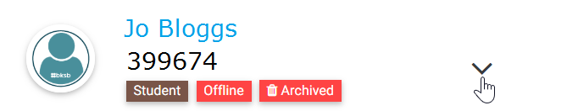
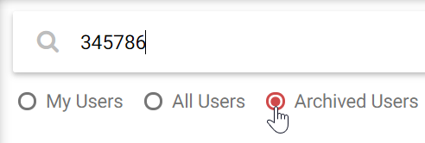
Q. Student has tried to log in but it says their account has been ‘archived’.
A. Any tutor (or member of LC team) can ‘restore’ their account like so:
Log into BKSB > Click Users, search under ‘archived users’ > expand the user, then restore.

Sticker on student’s ID card determines which assessment(s) they take in week 1:

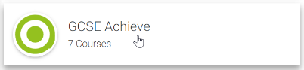
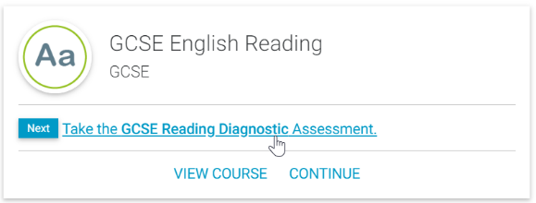
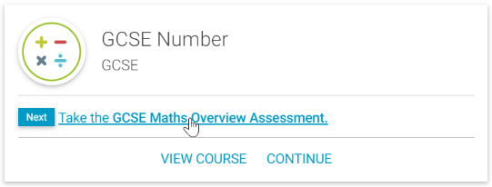
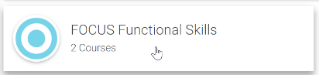
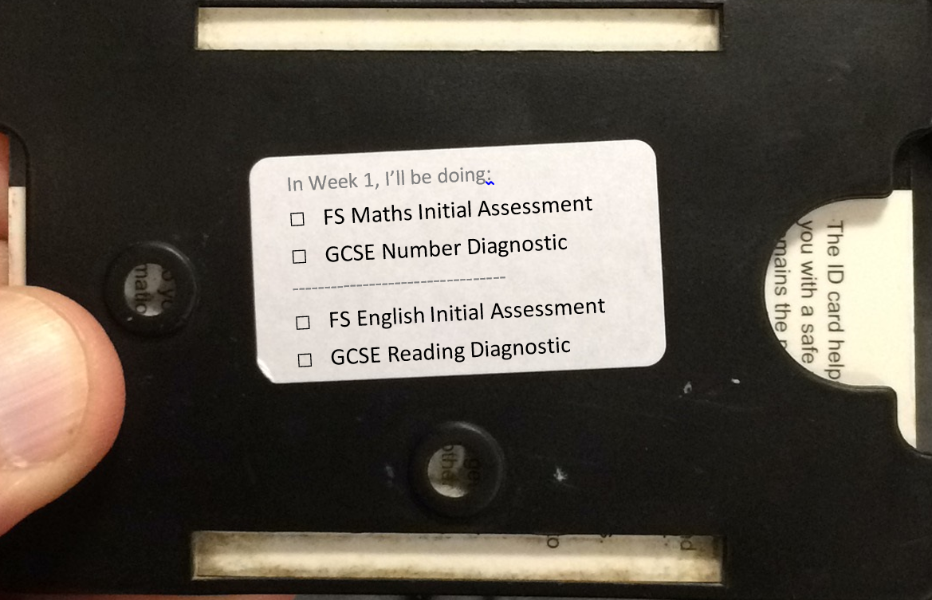
Take the Maths Initial Assessment
Take the English Initial Assessment
Log into BKSB, then…
Log into BKSB, then…

