Driver advice: winter and bad weather driving
Drivers can pledge to – slow right down in bad weather and avoid driving at all if possible.
Weather can be unpredictable and turn quickly, making roads treacherous. Ice, snow, heavy rain, and fog significantly increase the risks on roads. Stopping distances can double in the wet and increase ten-fold in ice and snow, and if you can’t see clearly, you can’t react to hazards. Hence driving in bad weather can be lethal.
Brake urges drivers to follow the A, B, C of staying safe in winter and bad weather conditions.

Avoid driving
If possible, avoid driving in snow and other treacherous conditions. Never set off when it's snowing heavily or if it’s forecast to snow, and avoid driving if you possibly can in other bad conditions like fog, heavy rain and ice. Consider alternatives like public transport. If you drive to work, speak to your employer in advance about home-working arrangements when the weather is bad, especially if you live in a rural area prone to flooding or snow.

Be prepared
Even if you avoid setting off in dangerous weather conditions, you could get caught out, so be prepared by: - ensuring your vehicle is well-maintained through an up-to-date MOT, regular service, and regular walk-round checks by you
- regularly checking tyres to ensure they’re in good condition and have a tread depth of at least 3mm to be safe in the wet.
- making sure there is anti-freeze in your radiator and windscreen washer bottle. 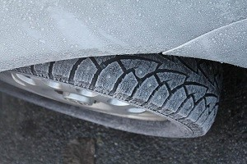
- keeping an ice-scraper and de-icer in your vehicle at all times in winter.
- packing a winter driving kit in case of emergency. This might include: a torch; cloths; a blanket and warm clothes; food and drink; first-aid kit; spade; warning triangle; and high-visibility vest.
- always take a well-charged phone in case of emergencies, but don't be tempted to use it when driving.
Car batteries are more likely to die in winter, so take steps to ensure yours doesn’t. If your car battery is old (more than five years) or there is sign of it struggling to start the car, get it checked by your garage and replaced if needed.
Clear ice, snow and condensation completely from your windscreen and all windows before setting off. Clear snow off the roof of your vehicle too, as it might fall and obscure your vision during your journey.
Check forecasts and plan your route carefully. In bad weather, major roads are more likely to be cleared and gritted. Allow plenty of time for potential hold-ups. The Met Office provides up to date forecasts, and issues warnings when severe weather is likely.

Careful, cautious driving
If you do get caught in bad weather, follow these steps to minimise the dangers.
Slow right down: if visibility is poor or the road is wet or icy, it will take you longer to react to hazards and you should reduce your speed accordingly. Take corners very slowly, and reduce speed further if your view of the road ahead is obscured. Always stay well within the speed limit and look out for temporary speed limit signs. Never speed up suddenly if fog seems to have cleared. Fog can be patchy and you may suddenly re-enter it.
Maintain a safe gap behind the vehicle in front: the gap between you and the vehicle in front is your braking space in a crisis. In wet conditions you should leave four seconds, and in ice or snow, drop right back as much as possible. Stopping distances are double in the wet, and can be ten times greater in icy weather. Never hang on someone else's taillights. This can provide a false sense of security and mean you're not fully focused on the road.
Be extra vigilant for people and hazards: be aware that people on foot, bicycles, motorbikes and horses are harder to spot in adverse weather. Drive slowly and cautiously so you are able to spot vulnerable road users in plenty of time and not put them in danger. Look out for signs warning of hazards, people, adverse conditions or temporary lower speed limits.
Stay in control: avoid harsh braking and acceleration, and carry out manoeuvres very slowly and with extra care.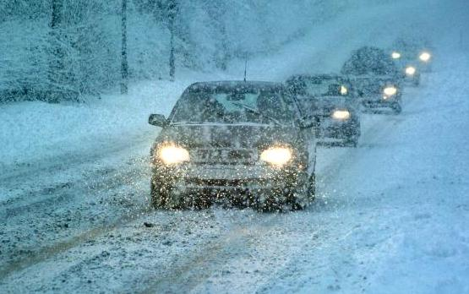
Use lights: put lights on in gloomy weather and when visibility is reduced. Use front and rear fog lights in dense fog. Remember to switch off fog lights when visibility improves.
Snow and ice: follow these tips if you get caught driving in snow and ice:
- use the highest gear possible to avoid wheel spin, but taking care not to let your speed creep up.
- brake gently to avoid locking the wheels. Get into a low gear earlier than normal and allow the speed of the vehicle to fall gradually.
- take corners very slowly and steer gently and steadily to avoid skidding. Never brake if the vehicle skids, instead, ease off the accelerator and steer slightly into the direction of the skid until you gain control.
- If stuck in snow, do not spin the wheels or rev the vehicle, as this will dig the vehicle further in. Instead, put the vehicle into as high a gear as possible and slowly manoeuvre the vehicle lightly forwards and backwards to gently creep out.
- if you are stuck fast, stay in the vehicle unless help is visible within 100 yards. Do not abandon your vehicle as this can hold up rescue vehicles.
Rain and floods: follow these tips if you get caught driving in heavy rain and floods:
- keep well back from the vehicle in front as the rain and spray makes it difficult to see and be seen.
- look out for steering becoming unresponsive, which can happen if water prevents the tyres from gripping. If this occurs, ease off the accelerator and gradually slow down. If possible, pull over somewhere safe until the rain stops and the water drains away.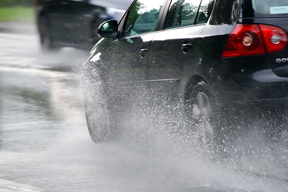
- never attempt to cross a flooded road if you are unsure how deep it is; only cross if you can see the road through the water. Apart from potential damage, many vehicles require only two feet of water to float.
- if driving on a flooded road, stay in first gear with the engine speed high and drive very slowly. Do not drive through floodwater if a vehicle is coming the other way. If possible, drive in the middle of the road to avoid deeper water near the kerb.
- test brakes immediately after driving through water by driving slowly over a flat surface and pressing the brakes gently. Warn passengers first.
In high winds: take extra care passing over bridges or on open stretches of road exposed to strong winds. If your vehicle is being blown about, slow right down and take great care to maintain a steady course. Keep well back from motorcycles and high-sided vehicles as they can be particularly affected by turbulence.
In winter sun: dazzle from low winter sun can be dangerous. Keep a pair of sunglasses in the vehicle all year round (prescription if needed) and keep your windscreen clean. Wear your sunglasses in bright sunshine, especially if the sun is low or reflecting off a wet road.
Gritted roads: the Highways Agency is responsible for keeping England's motorways and major 'A' roads clear of ice and snow, and local road networks are the responsibility of local authorities. In some cases there may be a lag before roads are treated so never assume that roads have been gritted.
- Pledge to slow right down for bad weather and avoid driving at all if possible
- See our advice for drivers on other road safety topics

