How do I retrieve files from the previous Moodle?
The upgrade to Moodle 2 will be a little different to the past upgrades. Whereas we normally upgraded the existing system, this system will be running alongside the old one.

New system: www.vle.hrc.ac.uk
Old system: www.moodle.hrc.ac.uk

This means files cannot be imported directly from -13 to -14 courses. If there are files you want to carry over from an old Moodle course, this guide is for you.

This guide describes the quickest method of downloading files from an old Moodle course to your computer. Once on your computer, any relevant files can be uploaded quickly to a Moodle 2 course (see the guide: Adding a file to your course).

Important: This does not work for activities. If you have laboured over activities in Moodle 1.9 (e.g. Moodle Quizzes) and need one or more moving over to Moodle 2, please contact the e-Learning team to discuss.
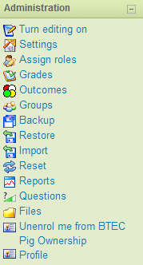

- Getting your files from Moodle 1.9

- Navigate to the course you wish to get the files from.
- Click the Files button in the Administration block on the left of the course page.
- You will now see a list of files and folders. Tick the boxes next to the files/folders you would like to take. Alternatively, you can click ‘Select all’. (Be critical – only tick what you need as the more files you choose, the longer they’ll take to download.)

- Scroll down to the bottom of the page and use the drop down box to select ‘Create zip archive’. This is a compressed folder you are creating. (This means the files are shrunk in size so they take up less data. Once the files are unzipped, they will revert to their original sizes. This won’t harm your files.)

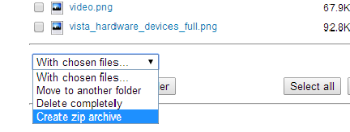

- You will now be taken to a page listing all the items you are zipping. Scroll down to the bottom of this and choose a name for your new folder, then click ‘Create zip archive’.

- You will then be taken back to the files area where you can now see your zipped folder listed. It will be displayed as (whatever you named the folder).zip

- Click this zipped folder to begin downloading it. This will take a while if you are zipping a lot of content.

- The download will take place in a window that pops up. In the bottom left of this window will be your zipped folder. Once the folder has finished downloading…
…drag it onto your desktop or into another folder (e.g. My documents) or your USB stick; whatever works best for you.

- Unzipping your files

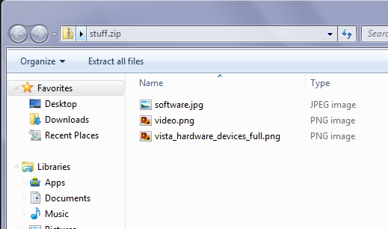
- Open your zipped folder by double-clicking on it.
- Click ‘Extract all files’

- You will now need to choose the folder on your PC that you will extract (unzip) the files to.
By default, it will be in the same location that the zipped folder was in. In my case, that is the desktop (see below) but you can click Browse and choose another location, e.g. an empty folder you’ve created in My Documents.

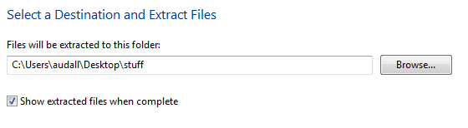
Leave this box checked

You now have a normal folder of files on your computer. You can upload any of the files to a Moodle course in the new system by following the Adding a File to your Course guide.

Nb. You no longer need the zipped up version of the folder - it can be deleted.

