How do I Enrol a Teacher on a Course?

Any teacher can assign other teachers to a course.
They can also unassign teachers, including themselves.
However unassigning a teacher that is timetabled for a course means they will be automatically enrolled overnight.
Students do not need to be enrolled, this process is all automated.

To enrol a teacher on your course, scroll down to the Administration block on the left side of the course and click the tab to expand it.
Then click on

This will take you to a list of existing enrolled users and their roles.

Click on ‘Enrol users to the bottom right of the table.

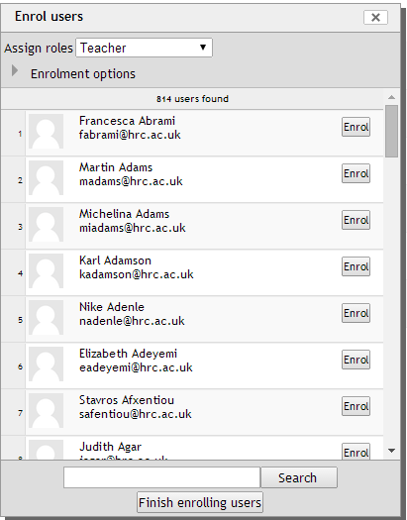
You should now see this window.

Select the correct role in the drop down at the top of the window.

Search for the teacher’s name.

Click the Enrol button to the right of the correct user.

To unassign a role, go back to the table and click the X next to the role you wish to remove.

