Adding a File to your Course
IMPORTANT: Adding a file to your course page on Moodle 2 is as simple as dragging and dropping, provided you are using an up-to-date Internet browser.
(Minimum versions: Internet Explorer 10, most Chrome versions or Safari 6).

This summer, the IT team is upgrading all staff and student PCs to Internet Explorer 11 and Google Chrome – both of which work very well with Moodle 2.

In the interim, if you discover the PC that you are working on does not allow you to drag and drop into Moodle, you can download a ‘portable’ version of Google Chrome, which you can run on your PC without installing anything. See the Moodle homepage for details vle.hrc.ac.uk

How to Drag & Drop files into Moodle

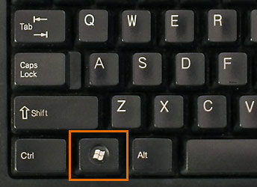
- Open the relevant Moodle course, hold the Windows key and then press the left arrow key while still holding the windows key down! This will make the web browser ‘snap’ to the left side of your screen.

- Now open the folder containing the files you want to add and do the same, this time with the right arrow key. What you should get is a split screen something like this (Moodle on left, folder on right):
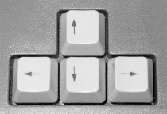
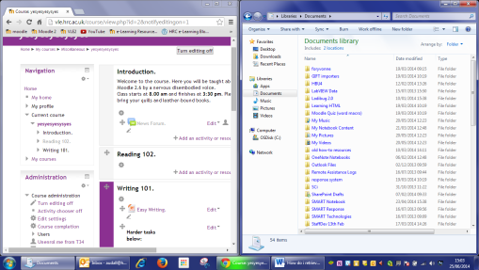

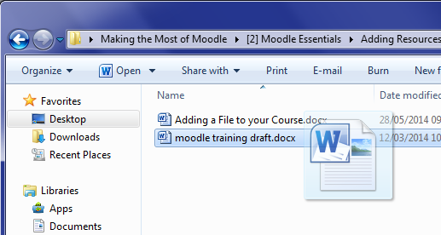
- Click turn editing on in Moodle and drag your file from its folder, straight onto the course page! This also works for multiple files at once but not folders.

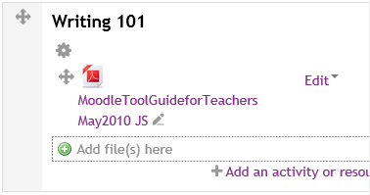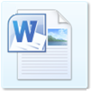But what if you want to put your files into folders on the course page, like this?

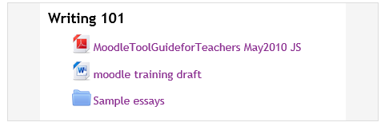
Easy. Create a folder and add content to it like so:
- With editing turned on, click on the right side of the relevant topic box and select followed by ‘Add’
- Give the folder a name and a short description. The description is required; it will display inside the folder, above any files. If desired, you can check the box to have the description display on the course page.
- You will then see this box. Drag any files into it from your computer (you can drag multiple files at once).
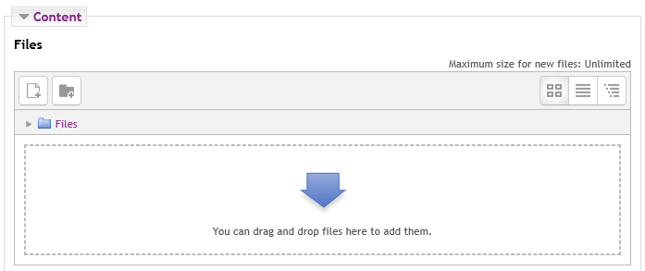

- Click ‘Save and return to course’ to go back to the course page.
________________________________________________________________________________
From now on, you can add or remove files to/from that folder as required, like so:
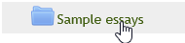
Click the folder name on the course page…

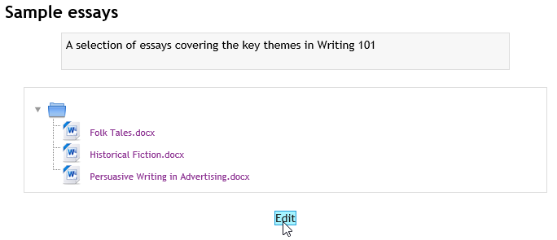
Click Edit beneath the list of files (then drag more files in or click a file then click delete).

